(Approx. 1167 words)

Thank Ben Franklin – For the Library, that is
By Phil Sorrentino, Contributing Writer, Sun City Summerlin Computer Club
www.scccomputerclub.org
philsorr (at) yahoo.com

Ben Franklin is remembered for many things political and technical. I’ll leave the politics to the history buffs, but on the technical side, he invented the Lightening rod, bifocal glasses, the Franklin Stove for home heating, and the odometer. And most important to us lately, he laid the groundwork for the public library system.
Libraries have changed a lot since Franklin’s time, but the idea of a source of information or entertainment to be loaned out for free, to members, has endured for almost 300 years. Initially, books were probably the only things being loaned out, but nowadays the library loans out eBooks and audible books, as well as movie DVDs, music CDs, and TV shows, and the always popular classically bound books, many of which are mercifully in Large Print. Although initially and up to just a few years ago, a person had to visit the library to borrow an item, today we have computers, tablets, and phones that allow us to borrow an item without ever having to show up at the library. (However, you probably have to go once just to join the library and get a library card, though that, recently, may have even migrated to online activity.)
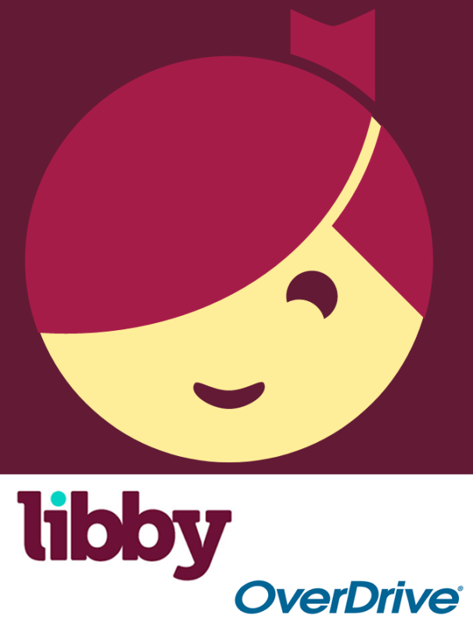
OverDrive Icon Libby Icon
Today, most public libraries subscribe to a service called OverDrive to catalog and manage their electronic offerings. When you borrow an electronic item, you download a license file to your computer. The license file is an .acsm file type, for those of you interested in the details. So, borrowing an electronic item entails downloading the item's license file to your device and then using the appropriate reader/viewer/player to read/view or play the electronic item. And don’t worry about returning the item because after the borrowing period ends, the item will automatically be returned to the library (No Late Fees, pretty neat, don’t you think).
You can even return the item early if you finish it before the borrowing period ends; just look for a button to “Return” the book. Fortunately, all of the steps required to borrow and return an item are done for you by an app that you initially download to your device. Once it is downloaded, you then use it to borrow the electronic items. When you first use the app to connect you to your local Library system, you will establish an account with an account name (usually your library card number) and a password or PIN. This is now the account you will use to borrow electronic items. Two of these apps are Overdrive and Libby, both of which are used to borrow eBooks and audible books. Overdrive has been around for a while and allows you to borrow eBooks and audible books so you can then read them with a reader like the Kindle reader. Libby is newer. Not surprisingly, Libby is made by the same company that makes OverDrive - the OverDrive Company. Libby not only helps you borrow the item, but it provides a reading environment, so you can borrow and read eBooks or listen to audible books, all within Libby. (So, you don’t need the Kindle reader if you use Libby.)
eBooks and Audible books are typically shown in a library-like view, and you will have an opportunity to borrow any available item, i.e. the book’s license has not checked out. If you find a book that you are interested in, typically you can borrow the book just by clicking on “borrow.” The book (license file) will be downloaded to your device and you will be able to read or play it with an appropriate reader or player, for the amount of time specified by your library. Just like physical books, these electronic books can only be borrowed by one person at a time. If an item is checked out by someone else, the item will show up as not available and you will see an option to place a hold on the item. Once you place a hold on an item, it will be added to the “hold” section of your account. When it becomes available, you will typically get a “book available” notification email. Just as an example, an eBook borrowed from the Hillsborough County library, using Overdrive can be kept for 14 days.
Many of us may remember Hoopla, Fran & Ollie, or was that Kookla, Fran & Ollie. (Well, that probably gives away the fact that I grew up in the 1950s near New York City.) But the important point here is that Hoopla is a new free Streaming service being offered by many library systems, in particular the Hillsborough County Public Library Cooperative. (HCPLC). Many of us are probably familiar with borrowing eBooks and audible books from the library using Overdrive or Libby on our mobile devices (phones and tablets), but Hoopla goes a step beyond and provides free streaming of much of the library’s video inventory. Hoopla is a cloud-based digital media platform that enables users to instantly borrow entertainment and educational material using the Hoopla app on a tablet or smartphone. Think of Hoopla as pay-per-view or video streaming, where your public library is picking up the cost.
Hoopla is a website (Server) and app (Client for mobile devices) that allows you to borrow movies, TV (shows & episodes), and Music selections. The website is hoopladigital.com and the App looks like this:
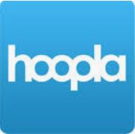
All streaming services are vying for your time and most are also after your money, but Hoopla is free. Hoopla is more like a library than a “blockbuster” store (for those of you who can remember that far back). All you need is a library card and you can get an account. Once you have an account, you can borrow movies, TV shows, music CDs, eBooks, audible books, and comics (cartoons). When you borrow these items, like borrowing items from any library there are some restrictions. Libraries have different limits, so check with your particular library system. Libraries may limit the number of items borrowed per month, or the amount of time you may have access to the item. HCPLC allows you to borrow 20 movies per month. When you borrow a movie, you can have it for up to 3 days. CDs borrowed via Hoopla are good for 7 days and audiobooks are good for 21 days. A quick look at HCPLC revealed over 12 thousand movie titles, over 2 thousand TV show episodes, over 45 thousand CD titles, over 180 thousand eBooks, over 51 thousand audible book titles, and over 10 thousand comics (cartoons) listed. With that much free streaming from the library, you may not need all those costly streaming subscriptions, though I doubt if Hoopla will replace any of the popular streaming sites like Netflix or Amazon. It is probably just a free adjunct, but if funds are tight it may just be a good free alternative.

